## **Name : Junaid Ahmed**

## **ID: BIT-23F-030**

## **Section: “3A”**

## **Lab: 07**

## **Subject: Artificial Intelligence**

## **Program: BS-IT**

TASK-01 : Write a Python function that draws a square using asterisks (*). The side length of the square should be provided by the user.

## Program:

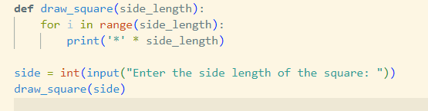

## Output:

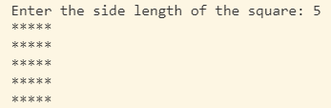

TASK-02: Write a Python function that takes a list of numbers as input and returns the sum of only the even numbers.

## Program:

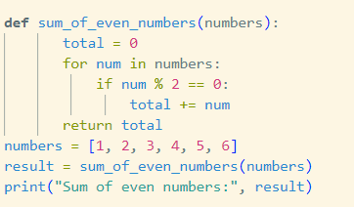

## Output:



TASK-03 : Write a Python function that takes a number as input and counts down to zero, printing each number.

## Program:

## 

## Output:

